# Revamping of UAJK Portal Unveiling New Dimensions through Virtual Exploration



**By**

**SAMI GUL**

**Reg No**

**2020-UMDB-000859**

**ZOHAIB ALI SHAH**

**Reg No**

**2020-UMDB-001396**

**Supervisor**

**Dr. Syed Zaki Hassan Kazmi**

**Assistant Professor**

**DEPARTMENTOFCOMPUTERSCIENCES& INFORMATION TECHNOLOGY**

**FACULTY OF SCIENCESUNIVERSITYAZADJAMMU&KASHMIR**

**MUZAFFARABAD**

**Session: 2020-2024**

**APPROVAL CERTIFICATE**



It is certified that the project work presented in this report entitled “Revamping of UAJK Portal: Unveiling New Dimensions through Virtual Exploration” submitted by Sami Gul (Roll No. 01) and Syed Zohaib Ali Shah (Roll No. 45) Session (2020-24) supervised by Dr. Syed Zaki Hassan Kazmi in our opinion is fully adequate in scope and quality of Bachelor’s of Science (BS).

_________________ __________________

## (Supervisor) (External Examiner)

Dr. Syed Zaki Hassan Kazmi

Assistant Professor

Department of CS & IT,

University of Azad Jammu & Kashmir

Muzaffarabad

_________________

(Chairman)

Dr. Syed Ali Abbas

Department of CS & IT

University of Azad Jammu & Kashmir

Muzaffarabad

## ABSTRACT

The University of Azad Jammu & Kashmir is a rich cultural as well as academic atmosphere-scented institution. Under "**Revamping of UAJK Portal: Unveiling New Dimensions through Virtual Exploration**", the web portal is going to provide the new look of campus that has become a smart inter-act student, staff, and visitor webpage. In that context, let one thing be mentioned clearly in which a virtual complete tour over the whole campus could be managed by vivid visualizations of 3D view. From academic buildings to scenic spots around the campus, users will be able to immerse themselves in realistic virtual experience.  
Imagine a potential student or visitor navigating UAJK from the comfort of their home—browsing academic departments, locating facilities, and planning visits based on the virtual map. The portal will also have resources such as contact information, event calendars, and news updates, all very easy to access.  
The new UAJK portal will have a seamless experience with fast performance powered by React and Node.js. It also offers offline functionality to ensure the access of the most basic campus information in areas where connectivity may be limited.

## UNDERTAKING

I certify that the research work titled **“Revamping of UAJK Portal: Unveiling New Dimensions through Virtual Exploration”** is my own work. The work has not been presented elsewhere for assessment. Where material has been used from other sources, it has been properly acknowledged and referenced.

Signature of Student

Sami Gul

2020-UMDB-000859

Syed Zohaib Ali Shah

2020-UMDB-001396

## ACKNOWLEDGEMENTS

All praise to Almighty Allah, the most merciful and beneficent, who enabled us to complete this project.

Words are inadequate to express my deepest sense of appreciation and devotion to our worthy supervisor, **Dr. Syed Zaki Hassan Kazmi**. We are extremely grateful for his scholarly and supportive attitude, inspiring guidance, generous assistance, constructive criticism, timely advice, and enlightened supervision in the accomplishment of this manuscript.

Special regards to the Chairman of the CS&IT department, faculty members, our colleagues, and our parents and families, whose continuous support has led us to the path of learning.

*"The roots of education are bitter, but the fruit is sweet." –* ***Aristotle***

## TABLE OF CONTENTS

Revamping of UAJK Portal:

Unveiling New Dimensions through Virtual Exploration..........................i

Approval Certificate..................................................................................ii

Abstract ....................................................................................................iii

Undertaking...............................................................................................iv

Acknowledgment.......................................................................................v

Table of contents........................................................................................vi

List of figures ...........................................................................................ix

List of tables ..............................................................................................x

CHAPTER 1: INTRODUCTION

1.1 Existing System .............................................................1

1.2 Proposed System ...........................................................2

1.3 Motivation .....................................................................3

1.4 Objectives ......................................................................3

1.5 Features ..........................................................................3

1.6 Software Process Model ................................................4

1.7 Feasibility Study ............................................................5

1.7.1 Technical Feasibility ...................................................5

1.7.2 Cost Feasibility ...........................................................5

1.7.3 Market Feasibility .......................................................6

1.7.4 Operational Feasibility ................................................6

1.7.5 Legal and Regulatory Feasibility ................................6

1.7.6 Social and Ethical Feasibility ......................................6

CHAPTER 2: REQUIREMENTS SPECIFICATIONS

2.1 Objective .......................................................................7

2.2 Scope .............................................................................7

2.3 Target Audience .............................................................7

2.4 Document arrangement...................................................8

2.5 Functional Requirements................................................8

2.6 Non-functional Requirements .......................................8

2.6.1 Usability .....................................................................9

2.6.2 Reliability .....................................................................9

2.6.3 Performance..................................................................9

2.6.4 Response Time..............................................................9

2.6.5 Purchase Components...................................................9

2.6.6 User Interface................................................................9

2.7 Software Interface............................................................9

2.7 Use Case Diagram...........................................................10

2.8 Use Case Description......................................................11

CHAPTER 3: DESIGN

3.1 Design ............................................................................19

3.2 Entity Relationship Diagram (ERD) ..............................19

3.2.1 Relationship .................................................................20

3.3 Class Diagram .................................................................21

3.4 Activity Diagram .............................................................21

3.4.1 User login activity ........................................................22

3.4.2 User registration activity ..............................................23  
 3.4.2 Admin Activity..............................................................24

3.5 System Sequence Diagram..............................................24

3.5.1 Admin Login Sequence ...............................................25

3.5.2 User Registration Sequence .........................................26

3.5.3 User Login Sequence ...................................................27

CHAPTER 4: IMPLEMENTATION

4.1 Language and Framework ................................................28

4.1.1 JavaScript ......................................................................28

4.1.2 React...............................................................................28

4.1.3 Node.js ...........................................................................28

4.1.4 Mongo DB .....................................................................28

4.1.5 Three.js...........................................................................29

4.1.6 Libraries..........................................................................29

4.1.7 Admin Panel...................................................................29

CHAPTER 5: TESTING

5.1 Unit Testing ......................................................................32

5.2 Integration Testing ...........................................................32

5.3 System Testing .................................................................32

5.4 Test case ...........................................................................33

CHAPTER 6: Appendix

6.1 Landing Page .................................................................35

6.2 Hero Section...................................................................35

6.3 Introduction Page...........................................................36

6.4 News Section..................................................................37

6.5 Login Page......................................................................37

6.6 Signup Pages..................................................................38

6.7 Admin login Page...........................................................38

6.8 Admin Office..................................................................39

6.9 Virtual Tour.....................................................................40

6.10 Department Page...........................................................41

6.11 Student Dashboard........................................................42

6.12 Admin Dashboard.........................................................42

Conclusion and Recommendations ..........................................................43

References ................................................................................................46

#### LIST OF FIGURES

*Number Page*

Figure 1.1: Waterfall Mode……………………………...…………….4

Figure 2.1: Use case Diagram...............................................................10

Figure 3.1: Entity Relationship Diagram (ERD)…….……… ………19

Figure 3.2: Class Diagram………………………...………………….21

Figure 3.3: User login activity ..............................................................22

Figure 3.4: User registration activity ....................................................23

Figure 3.5: Admin activity diagram ..................................................... 24

Figure 3.6: Admin login sequence ........................................................25

Figure 3.7: User registration sequence .................................................26

Figure 3.8: User login sequence ...........................................................27

Figure 5.1: Testing Triangle .................................................................31

## LIST OF TABLES

*Number page*

Table:2.1 Use Case Description..........................................11

Table: 2.2 Use Case Description ........................................11

Table: 2.3 Use Case Description.........................................12

Table: 2.4 Use Case Description.........................................12

Table: 2.5 Use Case Description ........................................13

Table: 2.6 Use Case Description.........................................14

Table: 2.7 Use Case Description..........................................14

Table: 2.8 Use Case Description..........................................15

Table: 2.9 Use Case Description..........................................15

Table: 2.10 Use Case Description........................................16

Table: 2.11 Use Case Description........................................17

Table: 2.12 Use Case Description........................................18

Table: 3.1 Relationships.......................................................20

# CHAPTER 1

# INTRODUCTON

Revamping of UAJK Portal is the latest effort that can be a complete resource for the University of Azad Jammu and Kashmir (UAJK), an enriching experience that connects students, faculty, and visitors to the vibrant academic and cultural landscape of the university. User experience has been emphasized most; valuable time is saved in guaranteeing accuracy and reliability in retrieving information. It is going to be realized with a renewed interface of a website, that will reflect a modern look and feel. Interactive animations will provide usability, thereby creating a fun environment, which symbolizes the spirit of UAJK from the moment that users enter the portal.  
The website is designed to enrich the existing system. Lots of interactive features are being introduced that would benefit users to a great extent while exploring and engaging in the offerings of UAJK. Our core mission is to make the journey through the university smooth, informed, and memorable. The portal will include details of almost everything regarding UAJK-from departments and facilities on campus to the hidden treasure’s unknown within the community of the university. The user will have access to all such relevant information as regards departments, courses, events, accommodation, transport services, and administrative support. The UAJK website, through web technology, will change the style of interaction between the user and the university.  
**1.1 Existing Systems**The current UAJK website is the main online interface of the university but is largely outdated and based on WordPress and, therefore cannot offer much functionality or responsiveness. Being outdated, it does not provide any basic information and meets not with modern user experience and accessibility standards. Several problems have been identified:  
•Scanty Information: The website does not provide ample information regarding the university's campuses, departments, and resources. This limits the users from getting hold of any useful information.  
•Old Design: The interface does not bring modern design elements to make it look more attractive and user-friendly.  
• No Virtual Tour Feature: There is no interactive virtual tour at the moment that would let prospective students and visitors view the campus online, thereby failing to engage them.  
• Static Content: This results in a static web use and lacks animation since the user cannot engage to make something dynamic happen;.  
• Actual events or announcements are not updated in time; update on essential issues about university.  
•Technological Limitations: Since most university websites are developed using the more contemporary frameworks such as ASP.NET or React, the present UAJK website is not enabled by contemporary web technologies and is, hence, less capable of growth and adjustment.  
The Revamping of UAJK Portal project is aimed at filling the gaps by making the website more modern, employing state-of-the-art web technologies, and adding a virtual tour to make it far more user-friendly.  
**1.2 System Proposal:**  
The proposed system looks at redesigning the existing UAJK website by incorporating a large number of new features and options that aim to enhance user experience for students, faculty, and visitors. The UAJK Portal is going to be an online source for information and services about the University of Azad Jammu and Kashmir (UAJK).  
Key features of the proposed system:  
• User-Friendly Interface: The New Website has a modern and friendly interface that allows easy navigation about different provisions, so should viewers really need access to essential information and services.  
• Campus Information: What UAJK has regarding the campus, departments, programs, and faculty will be made known to prospective students and visitors through this website.  
• Virtual tour: The virtual tour feature will allow the users to explore the campus online, thus providing an immersive experience on the campus facilities and environment.  
• Interactive Features: Interactive features and modern animations will be available to entertain users along with a dynamic browsing experience.  
These improvements would ensure that the UAJK website is modernized in appearance but, at the same time, a relevant tool for the university community for easy access by stakeholders toward having a successful and fulfilling experience at UAJK.  
**1.3 Motivation**  
The primary purpose of the revamping process of the UAJK Portal is to improve the digital presence of the University of Azad Jammu and Kashmir and to develop an interesting and informative student faculty and visitor site. To make the website contemporary in terms of being a valuable resource that clearly projects university strengths, offerings, and unique cultural heritage. It will help in incorporating a sense of community and belonging among current and prospective students, as well as faculty and staff. The website will easily become the gathering point for information related to academic programs, facilities, and events with easy access to all the required information.  
Moreover, with its rich past and cultural significance, the portal of UAJK will provoke more interaction within the university heritage and traditions. This approach to cultural promotion will enhance the reputation of the university and attract a wider audience, contributing to its growth and development. In the long run, the renewed UAJK Portal is going to serve the academic interests of its users and, most importantly, serve the development of the local community and economy since it will attract prospective students and facilitate local collaborations as well. UAJK aims to inspire discovery and learning and connection in their thriving academic environment through their up-to-date and user-friendly online platform.  
**1.4 Objectives**  
• Make the university website up-to-date, friendly, and accessible.  
• Speed Optimization: React/Next.js and Node.js for speed optimization of your website.  
• 3D Virtual Tour: Built using Three.js for an interactive campus exploration experience.  
• Improve Scavenger Hunt: Let users have an interactive campus exploration via virtual tour and an immersive journey.  
• Enhance Cyber Visibility: Combine innovative design, efficient performance with an interactive 3D virtual tour to enhance the university's presence through cyber space.  
**1.5 Features**  
• Completely refreshed modernly intuitive web interface with greatly enhanced navigation and accessibility.  
• The responsive website will look great on all devices such as desktops, mobile phones, and tablets.  
• React and Node.js have been used to decrease load times and enhance responsiveness.  
• Integration with Three.js for a 3D virtual tour of the university campus such that the user can explore it from anywhere.  
• Allows the university staff to administer news, announcements, and events with ease through an admin panel.  
• SEO best practices will be used to bring more visitors into the portal through eminent online visibility.  
• Campus maps in the virtual tour, navigating visitors around to departmental buildings, libraries, and hostels.  
• Role-based log-ins for both students, faculty, and administrative staff, including admin privileges for selected users.  
• A notification system to show important alerts or university updates in real-time.  
•The university news, events, and newsletters will have a designated space with filtering features.

## 1.6 Software process model

The software process model is an abstract representation of a software process, which is a set of activities that leads to the production of a software product.

Here is the waterfall model of the development of the software.

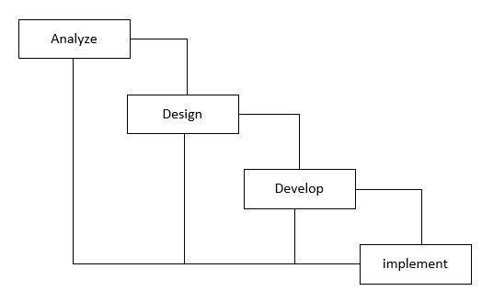

Fig 1.1: Waterfall model

* **Analyze:**
* Gather and analyze requirements from stakeholders, including functional (e.g., 3D virtual tour, content management) and non-functional (e.g., performance, responsiveness) needs.
* **Design:**
* Plan the system architecture, including UI/UX layout, backend structure, and database schema.
* Define integration points for React, Node.js, and Three.js technologies.
* **Develop:**
* Build the frontend using React and the backend with Node.js.
* Implement the 3D virtual campus tour and create a content management system.
* **Implement:**
* Integrate all components and perform testing to ensure functionality and performance.
* Deploy the final version of the portal and set up ongoing maintenance and updates based on user feedback.

## 1.7 Feasibility study

**1.7.1 Technical Feasibility**  
It uses the latest generation of the technology stack for building, including React on the frontend and Node.js on the backend for creating a dynamic, interactive user experience. The usage of Three.js makes it possible to create an interactive 3D virtual campus tour. Currently, all universities support web applications with their IT infrastructure, making deployment extremely easy. Project teams possess all the necessary skills and resources for development, ensuring the successful implementation. Therefore, the technical feasibility of the project is high with regard to scalability and future maintenance.  
**1.7.2 Cost Feasibility**

The long-run benefits of the "Revamping of UAJK Portal" will be enhanced user involvement and efficiency in operations outweighing the initial development costs. Funding could come from the university budget, research grants, and alumni. The ROI would be in better visibility, thus possible increase in student enrolment.  
While costs to maintain will be incurred, new technologies are less painful to update and scale; thus, future costs are reduced. Overall, this project provides a sustainable financial model for the university.  
**Market viability 1.7.3**  
Huge demand from the students, faculty, and prospective students for better online resources is what the market feasibility of the "Revamping of UAJK Portal" suggests. Competitive analysis reflects the need to keep the current designs updated and user-friendly. The feedback is towards improved navigation and interactivity, mainly the 3D virtual campus tour. Educational technology trends are expanding and supporting the objectives of the project. A targeted marketing strategy will promote the portal's launch and features to attract user engagement and visibility.

**1.7.4 Operational Feasibility**  
Revamping of UAJK Portal" evaluates the operational feasibility of the university in sustaining the project initiated by it after its launch.  
This IT system can host the new portal as well as support those technologies like React and Node.js. The staff will be trained appropriately on the use of the admin panel in content management. Technical support and systems updates will be there when technical issues arise. At large, the project can be well within the scope of the operational capacity for the university to ensure a sustainable management

**1.7.5 Legal and Regulatory Feasibility**  
Legal and regulatory feasibility of "Revamping of UAJK Portal" includes data protection law, such as GDPR, to ensure privacy of users and security of their data. The project will adhere to the policies of the university regarding digital content and accessibility standards. Relevant approvals and documentation will be taken from the concerned authorities before implementation. In short, the project is designed in a way that meets the legal requirements and reduces risks associated with non-compliance.  
**1.7.6 SOCIAL and ETHICAL Considerations**  
There is no ethical, security, and privacy issue that can affect the development, design, and ongoing running of the proposed system.

# CHAPTER 2

# REQUIRMENTS SPECIFICATIONS

**2.1 Objective**  
The "Revamping of UAJK Portal" is a project aimed at revitalizing the university's online appearance by modernizing the website with a view to an easier user experience and accessibility. In this regard, advanced technologies can be integrated to ease website navigation and provide an exciting 3D virtual campus tour.  
This requirement specification explicitly defines the functional and non-functional requirements of the "Revamping of UAJK Portal." It, therefore, guides the development team and stakeholders exactly to describe the desired behaviour and capability of the system in terms of its conformance to the objectives of the university and the requirements of users.  
**2.2 Scope**  
This document gives the scope of "Revamping of UAJK Portal," that includes all core functionalities, user interfaces, and integration with existing systems. Also, this document contains all the constraints and considerations which have to be taken into account in the course of development in order to provide successful implementation and user satisfaction.  
Included in the scope are features within an easy-to-use interface; responsive design; dynamic management of content; 3D virtual campus tour, which will also allow for secure user authentication; the portal will also ensure conformity with legal and regulatory stipulations, hence making it accessible and beneficial to all users.  
**2.3 Target Audience**  
The main audience of this requirement specification includes the development team, university management, and stakeholders involved in the "Revamping of UAJK Portal." Furthermore, it is also designed for anyone who is associated with testing, implementation, or even maintaining the system, so every party gets to know about the requirements and objectives of the project.  
**2.4 Document arrangement**  
This paper is divided into various sections in order to present systematically and elaborately the needs for the "Revamping of UAJK Portal." The sections that follow are:  
• Functional Requirements: Details on what functionalities the system ought to offer.  
• Non-Functional Requirements Specifications regarding performance, usability, security, and other operational characteristics important for the success of the system.  
**2.5 Functional Requirements**  
This describes the functional requirement of "Revamping of UAJK Portal." Functional requirements describe the basic features and functionalities of the system. This section will help in developing and ensuring the final product fulfils the requirements for needed utility, at the appropriate end, for the fulfilment of user needs. These are as follows:  
• **User registration:** Users may create accounts on the portal to retrieve access details.  
• **User Contact:** This system allows the contacting of the support or administrators for solutions or queries.  
• **3D Virtual Campus Tour:** Using a Three.js implemented 3D virtual tour, a user can have an interactive campus tour of the university.  
• **Content Management:** The campus portal enables the university staff to possess an admin panel in which they manage and update news, announcements, and events.  
• **Real-time Notifications:** the admin can send users push notifications about events, hotel offers, etc.  
• **Interactive Maps:** The virtual tour has embedded maps of the campus to navigate people through departments, libraries, and hostels.  
• **Role-based access:** Implement role-based access for students, faculty, and staff; this denies sensitive functionalities to unauthorized users.  
• **News and Events Section:** A dedicated section would be provided to share all university news, events, as well as newsletters with filter facilities.  
**2.6 Non-functional Requirements**  
Non-functional requirement for the "Revamping of UAJK Portal": This is on quality attribute and constraint, that would limit the system so as it would meet users' needs and performance expectations. Its key non-functional requirements include  
**•Performance:** The system should take no more than 2-8 seconds to load in normal operating conditions and sustain 500 concurrent users without degradation in performance.  
**•Usability:** The website should have an intuitive interface with easy navigation so that users can find information quickly and efficiently.  
• Build the portal such that it follows all the best practices on SEO, so that as much traffic as possible goes to the site.  
**•Security:** The system needs to implement robust security measures, including data encryption and secure user authentication, to avoid unauthorized access.  
**2.6.1 Fidelity**  
It is designed so that users are easy to interact with different opinions via the graphical user interface. The graphical user interface should be intuitive and easily understandable to users.  
**2.6.2 Reliability**  
The system is reliable friendly to users.  
**2.6.3 Performance**  
It performs well and yields a good result.  
**2.6.4 Response Time**  
It doesn't take much time the processing of information, queries, and user requests in the server but the user might face problems due to his slow internet connection. The end response time thus depends on the internet speed of the users.  
**2.6.5 Purchase Materials**  
The system is not using any off-the-shelf component. There are no purchased components and the system is built from scratch.  
**2.6.6 User Interface**  
It will have a friendly user interface, making it easy to use. This interface has been kept very simple and clutter free without too many confusing options. It has provided a simple interface and simple language has been used.

**2.7 Software Interfaces**

### 2.7.1 Use Case Diagram

Use case diagram is used to capture the dynamic nature of the system. It consists of use cases, actors, and their relationships. It is used at a high-level design to capture the requirements of a system.

**2.7.2 Use Case** 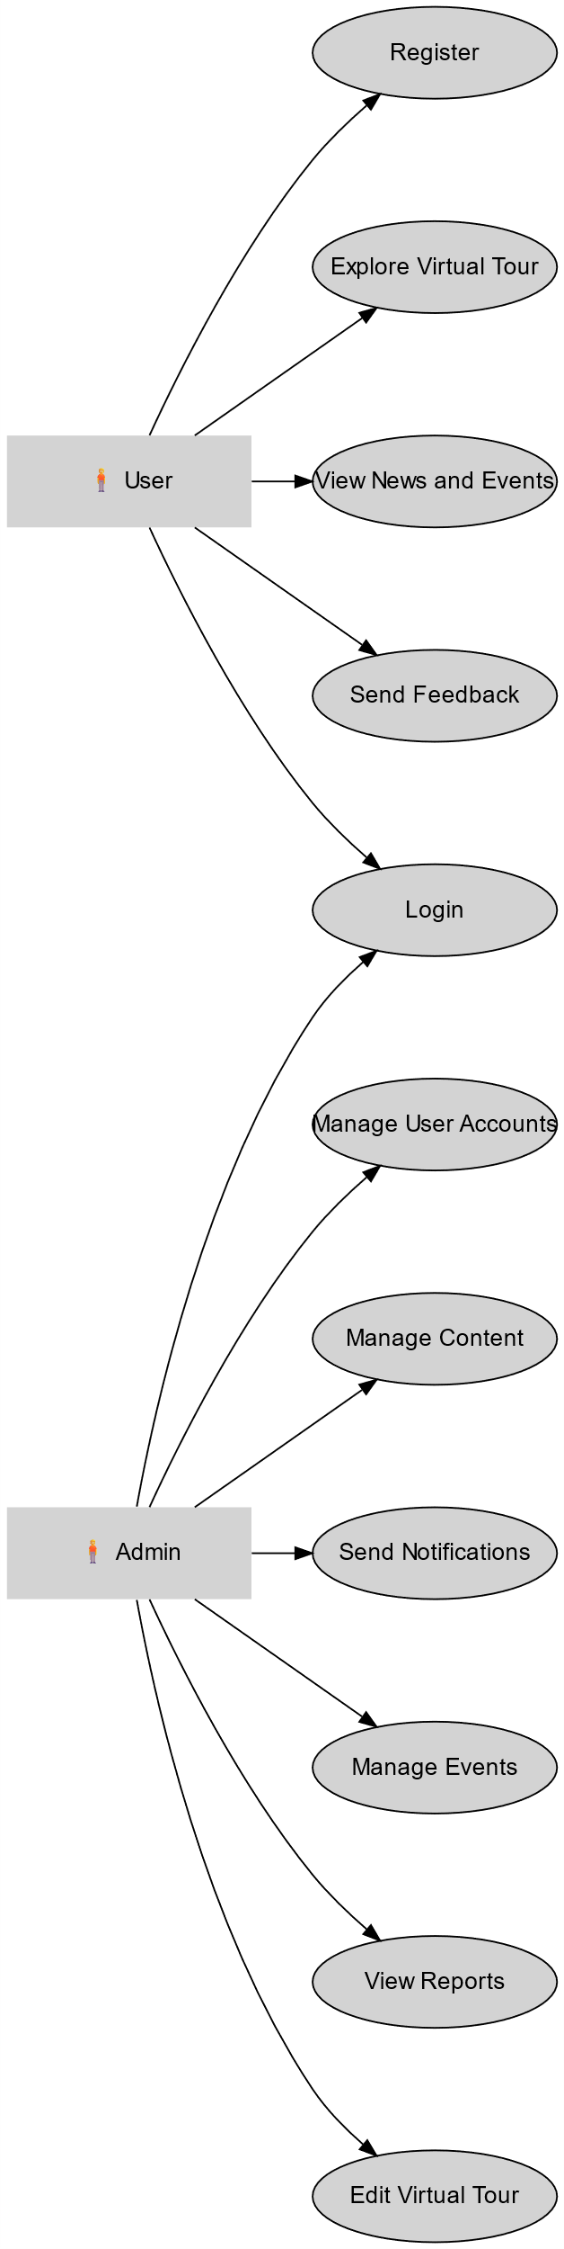

Fig 2.1: use case diagram

## 2.8 Use Case Description

Table 2.1: Use Case Description

|  |  |
| --- | --- |
| Use case no: | UC001 |
| Use case name: | Admin Login |
| Description: | Process of an administrator logging into the system to access administrative functionalities. |
| Actor: | Administrator |
| Trigger: | The administrator initiates the login process. |
| Pre-  Conditions: | 1. Valid user account registered. 2. System operational. 3. Internet access available |
| Procedures: | 1. Present login page.  2. Enter username and password.  3. Verify credentials. |
| Alternative | If password is forgotten, click "Forgot Password" and complete recovery steps. |

Table 2.2: Use Case Description

|  |  |
| --- | --- |
| Use case no: | UC002 |
| Use case name: | Manage User Accounts |
| Description: | Manage user accounts by creating, updating, or deleting user profiles. |
| Actor: | Administrator |
| Trigger: | Selects "Manage User Accounts" option. |
| Pre-  Conditions: | 1.Admin logged in.  2.System operational. |
| Procedures: | 1. Select to create/update/delete a user. 2. Fill in/update information. 3. Confirm deletion if applicable. |
| alternative | System alerts if the user account already exists during creation. |

Table 2.3: Use Case Description

|  |  |
| --- | --- |
| Use case no: | UC003 |
| Use case name: | |  | | --- | | Manage Content |  |  | | --- | |  | |
| Description: | |  | | --- | | Allows admin to create, edit, or delete content such as articles, events, and notifications. |  |  | | --- | |  | |
| Actor: | Administrator |
| Trigger: | |  | | --- | | Selects "Manage Content" from the dashboard. |  |  | | --- | |  | |
| Pre-  Conditions: | 1. Admin logged in. 2. Content management features available. |
| Procedures: | 1. Select content type to manage. 2. Create/edit/delete content. 3. Save changes. |
| Alternative | If an article is deleted, a confirmation prompt is shown. |

Table 2.4: Use Case Description

|  |  |
| --- | --- |
| Use case no: | UC004 |
| Use case name: | |  | | --- | | Send Notifications |  |  | | --- | |  | |
| Description: | Admin can send notifications to users about events, discounts, or important updates. |
| Actor: | Administrator |
| Trigger: | Selects "Send Notifications" option. |
| Pre-  Conditions: | 1. Admin logged in. 2. Notifications feature available. |
| Procedures: | * 1. Select notification type.   2. Compose message.   3. Select recipients.   4. Send notification. |
| Alternative | |  | | --- | | Review recipients if changes are needed before sending. |  |  | | --- | |  | |

Table 2.5: Use Case Description

|  |  |
| --- | --- |
| Use case no: | UC005 |
| Use case name: | |  | | --- | | View User Statistics |  |  | | --- | |  | |
| Description: | Admin can view statistics and analytics related to user engagement and system performance. |
| Actor: | Administrator |
| Trigger: | Selects "View Statistics" option. |
| Pre-  Conditions: | 1. Admin logged in. 2. Statistics feature available. |
| Procedures: | 1. Select desired statistic to view. 2. Review graphs and reports. |
| Alternative | |  | | --- | | Export statistics to CSV for offline analysis. |  |  | | --- | |  | |

Table 2.6: Use Case Description

|  |  |
| --- | --- |
| Use case no: | UC006 |
| Use case name: | |  | | --- | | Manage Settings |  |  | | --- | |  | |
| Description: | |  | | --- | | Allows admin to configure system settings such as user roles, permissions, and system parameters. |  |  | | --- | |  | |
| Actor: | Administrator |
| Trigger: | |  | | --- | | Selects "Manage Settings" from the dashboard. |  |  | | --- | |  | |
| Pre-  Conditions: | 1. Admin logged in. 2. Settings feature available. |
| Procedures: | 1. Access settings panel. 2. Adjust configurations. 3. Save changes. |
| Alternative | If settings are invalid, system prompts an error message. |

Table 2.7: Use Case Description

|  |  |
| --- | --- |
| Use case no: | UC007 |
| Use case name: | |  | | --- | | User Login |  |  | | --- | |  | |
| Description: | |  | | --- | | Process of a user logging into the system to access personalized features. |  |  | | --- | |  | |
| Actor: | User |
| Trigger: | |  | | --- | | User initiates the login process. |  |  | | --- | |  | |
| Pre-  Conditions: | 1. Valid user account registered. 2. System operational. 3. Internet access available. |
| Procedures: | 1. Present login page. 2. Enter username and password. 3. Verify credentials |
| Alternative | |  | | --- | | If password is forgotten, click "Forgot Password" and complete recovery steps. |  |  | | --- | |  | |

Table 2.8: Use Case Description

|  |  |
| --- | --- |
| Use case no: | UC008 |
| Use case name: | |  | | --- | | Explore Virtual Tour |  |  | | --- | |  | |
| Description: | Allows users to interact with the 3D virtual tour of the university campus. |
| Actor: | User |
| Trigger: | |  | | --- | | User selects "Explore Virtual Tour." |  |  | | --- | |  | |
| Pre-  Conditions: | 1. User logged in. 2. 3D virtual tour available. 3. The system must be operational and accessible . |
| Procedures: | 1. Load 3D virtual tour interface.  2. Navigate through the campus.  3. Interact with various points of interest. |
| Alternative | If loading issues occur, display troubleshooting steps. |

Table 2.9: Use Case Description

|  |  |
| --- | --- |
| Use case no: | UC009 |
| Use case name: | User Sign up |
| Description: | This use case describes the process of a user signing up for a new account in the system. |
| Actor: | user |
| Trigger: | The user initiates the sign-up process by providing the required information |
| Pre-  Conditions: | 1. The user must have access to the sign-up functionality within the system. 2. The system must be operational and accessible. |
| Procedures: | The system presents the sign-up page or registration form to the user.  The user fills in the required information, such as their full name, email address, username, password, and any additional relevant details.  The user submits the sign-up form.  The system validates the entered information to ensure it meets the defined criteria and format.  If the entered information is valid, the system creates a new  The system stores the user account information in the system's database.  The user receives a confirmation message or email indicating the successful creation of their account.  The user can now log in to the system using their registered email address or username and password. |
| Alternative | The system displays an error message indicating that the email address or username is already taken.  The user can provide a different email address or username and proceed with the sign-up process. |

Table 2.10: Use Case Description

|  |  |
| --- | --- |
| Use case no: | UC010 |
| Use case name: | Search for Content |
| Description: | |  | | --- | | Users can search for articles, events, or other information within the portal. |  |  | | --- | |  | |
| Actor: | user |
| Trigger: | |  | | --- | | User enters a search term in the search bar. |  |  | | --- | |  | |
| Pre-  Conditions: | 1. User logged in. 2. Search feature available. |
| Procedures: | 1. Enter search term.  2. Submit the search.  3. Review search results. |
| Alternative | |  | | --- | | No results found will prompt alternative suggestions. |  |  | | --- | |  | |

Table 2.11: Use Case Description

|  |  |
| --- | --- |
| Use case no: | UC011 |
| Use case name: | |  | | --- | | Submit Feedback |  |  | | --- | |  | |
| Description: | |  |  |  | | --- | --- | --- | | |  | | --- | | Users can submit feedback regarding their experiences on the portal or report issues. |  |  | | --- | |  | |  |  | | --- | |  | |
| Actor: | user |
| Trigger: | |  |  |  |  |  | | --- | --- | --- | --- | --- | | |  |  |  | | --- | --- | --- | | |  | | --- | | User selects "Submit Feedback" option. |  |  | | --- | |  | |  |  | | --- | |  | |  |  | | --- | |  | |
| Pre-  Conditions: | 1. User logged in. 2. Feedback form available. |
| Procedures: | 1. Access feedback form.  2. Fill in details.  3. Submit feedback. |
| Alternative | |  |  |  | | --- | --- | --- | | |  | | --- | | If feedback is incomplete, prompt the user to fill in required fields. |  |  | | --- | |  | |  |  | | --- | |  | |

Table 2.12: Use Case Description

|  |  |
| --- | --- |
| Use case no: | UC012 |
| Use case name: | View News Feed |
| Description: | |  |  |  | | --- | --- | --- | | |  | | --- | | Users can view a personalized news feed of updates and announcements relevant to them. |  |  | | --- | |  | |  |  | | --- | |  | |
| Actor: | user |
| Trigger: | |  |  |  | | --- | --- | --- | | |  | | --- | | User navigates to the news feed section. |  |  | | --- | |  |   . |  |  | | --- | |  | |
| Pre-  Conditions: | 1. User logged in. 2. News feed feature available |
| Procedures: | 1. Load news feed page. 2. Review updates and announcements. 3. Click on items for more information. |
| Alternative | No updates will prompt a message indicating no new content. |

# CHAPTER 3

# Design

## 3.1 Design

After a detailed analysis of the environment and requirements, we started to extract entities of the system with their essential attributes, and the relationship between them is established. This results in Entity-Relationship Diagram (ERD).

## 3.2 Entity Relationship Diagram (ERD)

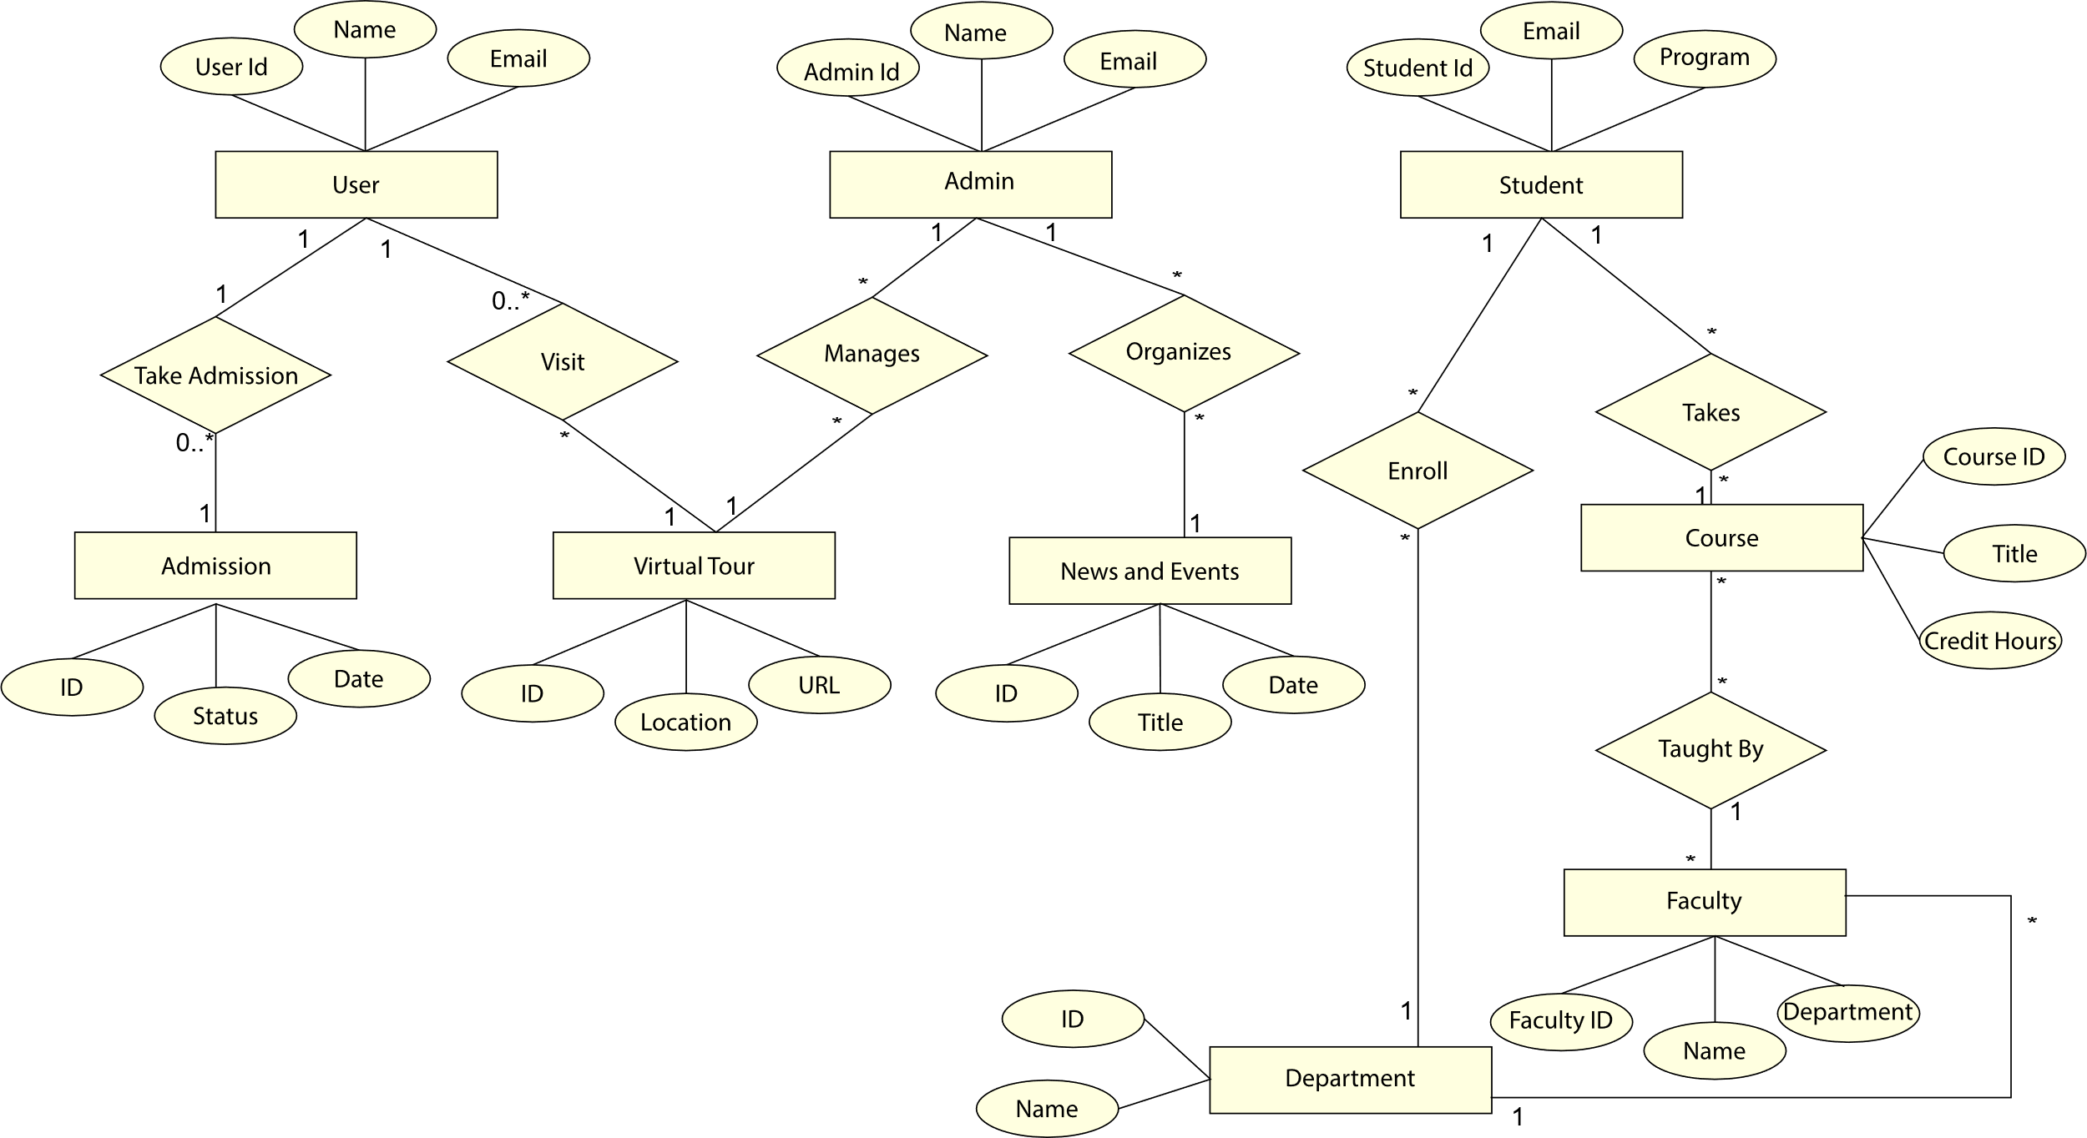

### Fig 3.1: ERD

#### 3.2.1 Relationship

|  |  |  |  |  |
| --- | --- | --- | --- | --- |
| **Entity**  **Name** | **Multiplicity** | **Relationship** | **Multiplicity** | **Entity**  **Name** |
| User | 1 | Takes Admission | 0..* | Admission |
| User | 1 | Visits | 0..* | VirtualTour |
| Student | 1 | Enrolls In | * | Department |
| Student | 1 | Takes | * | Course |
| Admin | 1 | Manages | * | VirtualTour |
| Admin | 1 | Organizes | * | Event |
| Course | * | Taught By | 1 | Faculty |
| Faculty | * | Belongs To | 1 | Department |
| Department | 1 | Offers | * | Course |
| News and events | * | Hosted By | 1 | Department |
| Admission | * | Linked With | 1 | Department |

Table 3.1: Relationship

## 3.3 Class Diagram

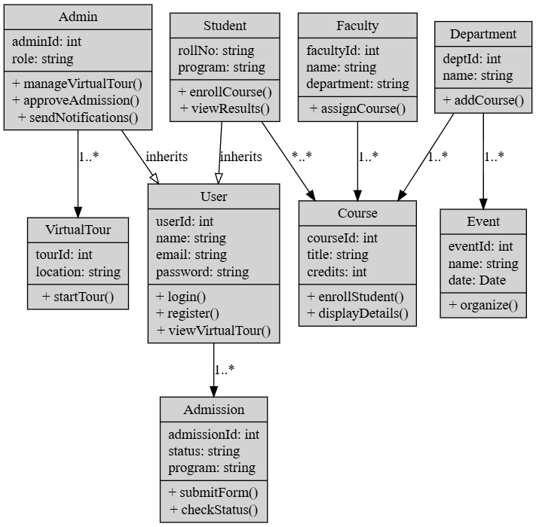

Fig 3.2**:** Class Diagram

## 3.4 Activity Diagram

Activity diagrams are used to capture the time ordering of message flow in a system. Message from user action flow towards system and system response message back to the user.

### 3.4.1 User Login Activity

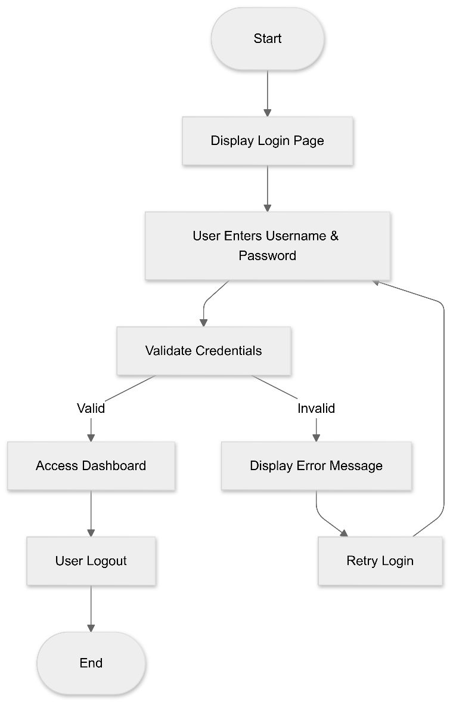

### Fig 3.3: User Login Activity

#### 3.4.2 User Registration Activity

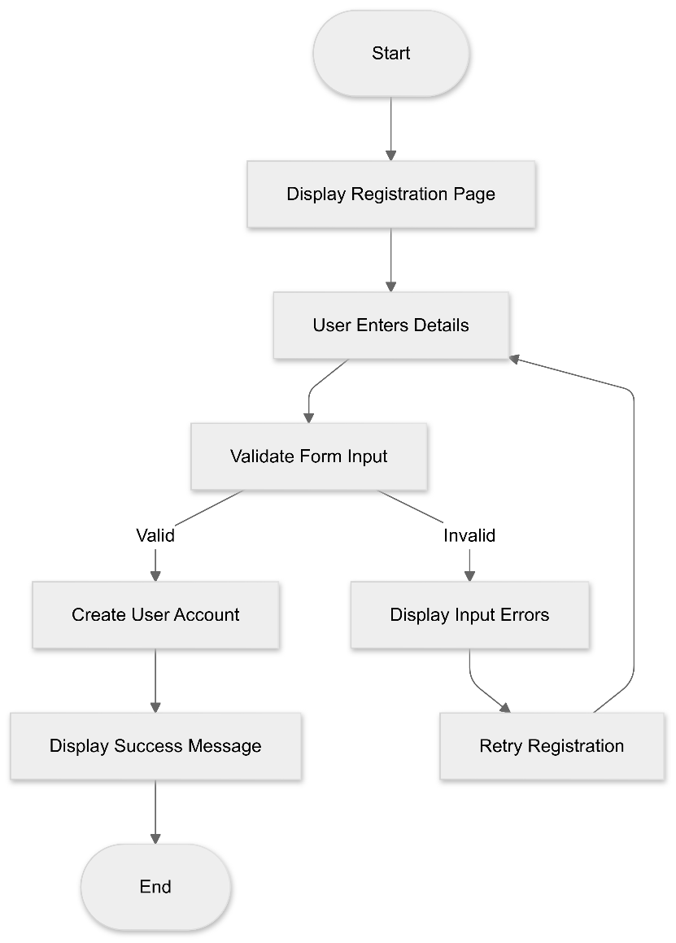

Fig 3.4**:** User Login Activity

#### Admin Activity Diagram

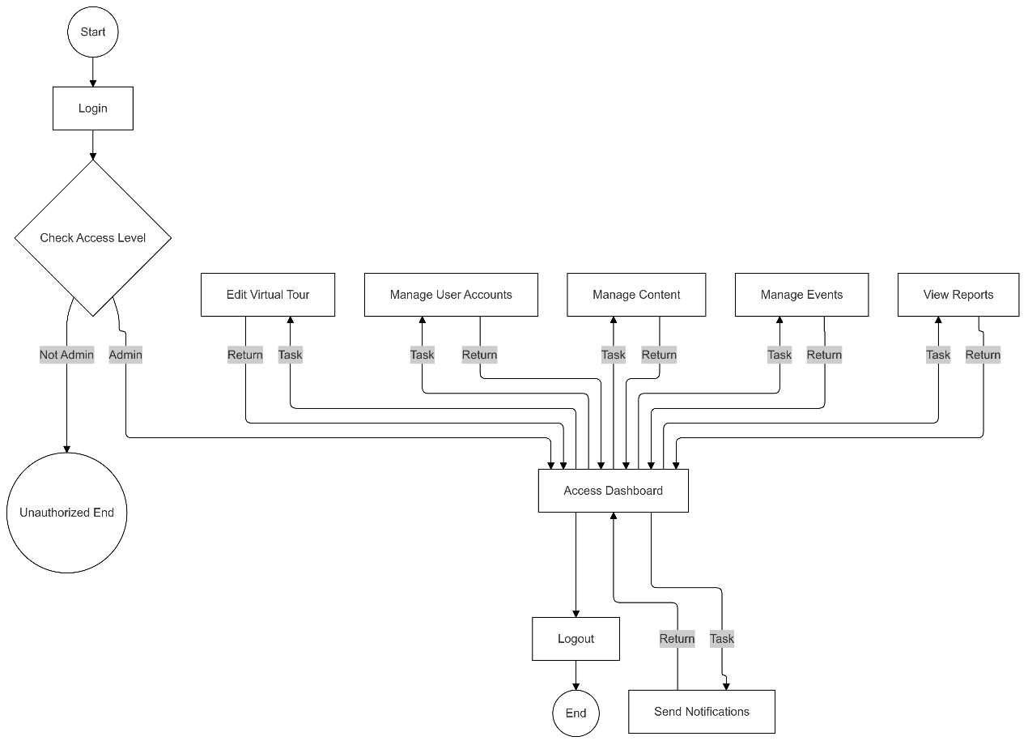

Fig 3.5**:** Admin ActivityDiagram

## 3.5 System Sequence Diagram

### 3.5.1 Admin Login Sequence

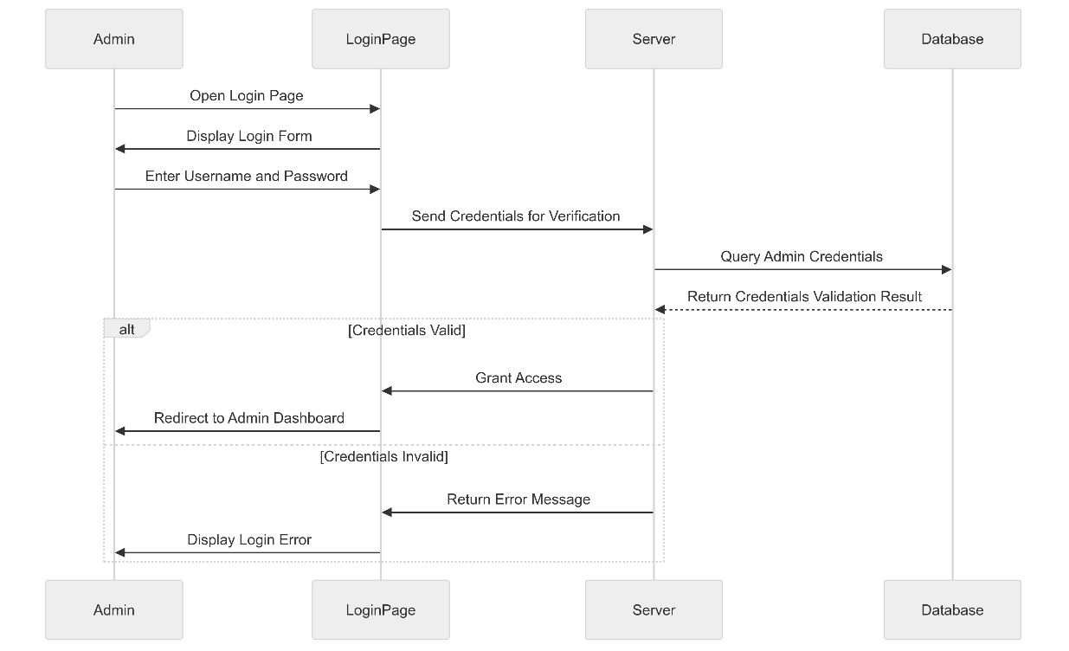

Fig 3.6**:** Admin Login Sequence

### 3.5.2 System Sequence Diagram

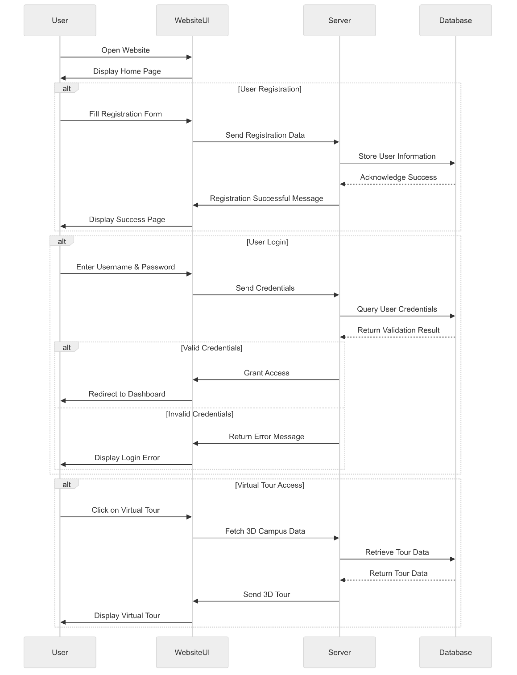

Fig 3.7**:** User Registration Sequence

### 3.5.2 Interaction Sequence Diagram

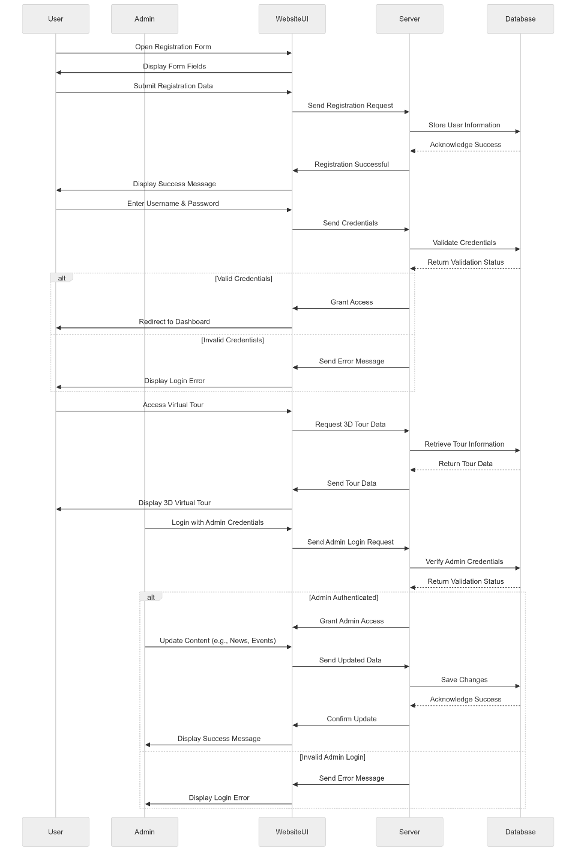

Fig 3.8**:** User Login Sequence

# CHAPTER 4

# Implementation

## 4.1 Language and Framework

The project "Revamping of UAJK Portal" leverages modern web development technologies to create a robust and interactive user experience. The following languages and frameworks are utilized:

#### 4.1.1 JavaScript:

The primary programming language for building dynamic and interactive web applications. JavaScript enables client-side scripting, allowing for responsive user interfaces.

#### 4.1.2 React:

A powerful JavaScript library for building user interfaces, particularly single-page applications. React allows for the creation of reusable UI components, enhancing code maintainability and performance.

#### 4.1.3 Node.js:

A runtime environment that enables the execution of JavaScript on the server side. Node.js is used for developing the backend of the application, facilitating efficient handling of client requests and interactions with the database.

#### 4.1.4 Mongo DB:

**MongoDB** is chosen for its flexibility, scalability, and ability to handle large volumes of unstructured data efficiently. Its document-oriented model enables faster development, and it excels at managing complex, nested data structures while providing robust querying capabilities.

#### 4.1.5 Three.js:

A JavaScript library used for creating 3D graphics in the web browser. Three.js will be utilized to develop the interactive 3D virtual tour of the university campus, providing an immersive experience for users.

#### 4.1.6 Libraries:

* gsap: For animations and micro interactions.
* express: For setting up the server.
* mongoose: To interact with MongoDB.
* bcryptjs: For hashing passwords.
* jsonwebtoken: To generate and verify tokens.
* dotenv: To manage environment variables.
* cors: To handle cross-origin requests.
* bcrypt: To hash the passwords
* multer: To handle file upload

### 4.1.7 Admin Panel

The Admin Panel encompasses the management of the 3D virtual tour, event updates, and the online admission system, streamlining administrative tasks for the university.

**Virtual Tour Management**

It allows administrators to oversee and update the virtual tour of the university campus. This module includes features for managing 3D models of campus buildings and amenities using tools like Three.js, enabling the addition, editing, or removal of virtual tour locations and points of interest. Furthermore, administrators can update multimedia content associated with specific tour stops, providing users with informative descriptions and visuals to enhance their virtual exploration.

**The Event Management**

This feature empowers the administration to effectively manage university events and announcements. This includes the ability to create, edit, and delete events, ensuring that accurate and timely information is shared with the university community. Administrators can schedule events for future dates and notify users through the portal or via email. Additionally, a calendar view of upcoming events is maintained for easy access and planning, ensuring that all members of the university are informed and engaged.

**Online Admission System**

It streamlines the admission process for prospective students through an intuitive online portal. Administrators can create and manage online admission forms, reviewing submissions in real-time and tracking the status of applications. This feature also facilitates communication of decisions to applicants, along with the generation of reports on admission trends and statistics to support better planning and resource allocation. Overall, this Admin Panel enhances the university's operational efficiency and improves the user experience for both administrators and students.

# CHAPTER 5

# TESTING

Testing is the process of evaluating a system or its component(s) with the intent to find that whether it satisfies the specified requirements or not. This activity results in the actual, expected and difference between their results. In simple words testing is executing a system in order to identify any gaps, errors or missing requirements in contrary to the actual desire or requirements. According to ANSI/IEEE 1059 standard,

Testing can be defined as “A process of analyzing a software item to detect the differences between existing and required conditions (that is defects/errors/bugs) and to evaluate the features of the software item”.

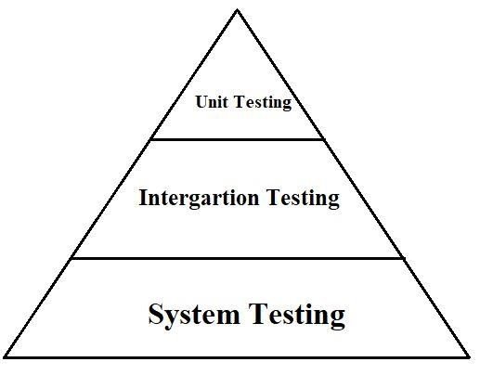

Fig 5.1**:** Testing Triangle

## 5.1 Unit Testing

This type of testing is performed by the developers before the setup is handed over to the testing team to formally execute the test cases. Unit testing is performed by the respective developers on the individual units of source code assigned areas. The developers use test data that is separate from the test data of the quality assurance team. The goal of unit testing is to isolate each part of the program and show that individual parts are correct in terms of requirements and functionality.

## 5.2 Integration Testing

The testing of combined parts of an application to determine if they function correctly together is Integration testing. There are two methods of doing Integration Testing Bottom-up Integration testing and Top-down Integration testing.

* Bottom-up integration testing begins with unit testing, followed by tests of progressively higher-level combinations of units called modules or builds.
* Top-Down integration testing, the highest-level modules are tested first and progressively lower-level modules are tested after that. In a comprehensive software development environment, bottom-up testing is usually done first, followed by topdown testing.

## 5.3 System Testing

* This is the next level in the testing and tests the system as a whole. Once all the components are integrated, the application as a whole is tested rigorously to see that it meets Quality Standards. This type of testing is performed by a specialized testing team.
* System Testing is the first step in the Software Development Life Cycle, where the application is tested as a whole.
* The application is tested thoroughly to verify that it meets the functional and technical specifications.

* The application is tested in an environment which is very close to the production environment where the application will be deployed.
* System Testing enables us to test, verify and validate both the business requirements as well as the Applications Architecture.

## 5.4 Test Case

**Test Case 1: Login Functionality**

**Test Case ID:** TC001  
**Objective:** Verify that an administrator can successfully log into the system.  
**Preconditions:** The administrator has a valid username and password.  
**Steps:**

1. Navigate to the login page.
2. Enter the valid username.
3. Enter the valid password.
4. Click the "Login" button.  
   **Expected Result:** The system should redirect the administrator to the dashboard, displaying a welcome message.  
   **Performed By:** **Sami Gul**

**Test Case 2: Admission Form Submission**

**Test Case ID:** TC002  
**Objective:** Validate that a user can successfully submit the online admission form.  
**Preconditions:** The user is on the admission page.  
**Steps:**

1. Fill in all required fields in the admission form.
2. Attach any necessary documents (e.g., transcripts, certificates).
3. Click the "Submit" button.  
   **Expected Result:** The system should display a confirmation message indicating that the admission form has been submitted successfully.  
   **Performed By:** **Sami Gul**

**Test Case 3: Virtual Tour Access**

**Test Case ID:** TC003  
**Objective:** Ensure that users can access the virtual tour feature of the website.  
**Preconditions:** The user is on the university homepage.  
**Steps:**

1. Click on the "Virtual Tour" link from the navigation menu.  
   **Expected Result:** The system should load the virtual tour interface, displaying an interactive 3D model of the campus.  
   **Performed By:** **Zohaib Ali Shah Kazmi**

**Test Case 4: Interface Link Functionality**

**Test Case ID:** TC004  
**Objective:** Check the functionality of all navigation links on the homepage.  
**Preconditions:** The user is on the homepage.  
**Steps:**

1. Click on each navigation link (e.g., Admission, Courses, Contact Us).  
   **Expected Result:** Each link should redirect to the corresponding page without errors, ensuring that all links are functioning properly.  
   **Performed By:** **Zohaib Ali Shah Kazmi**

## Appendix

## • Landing page



## • Hero Section

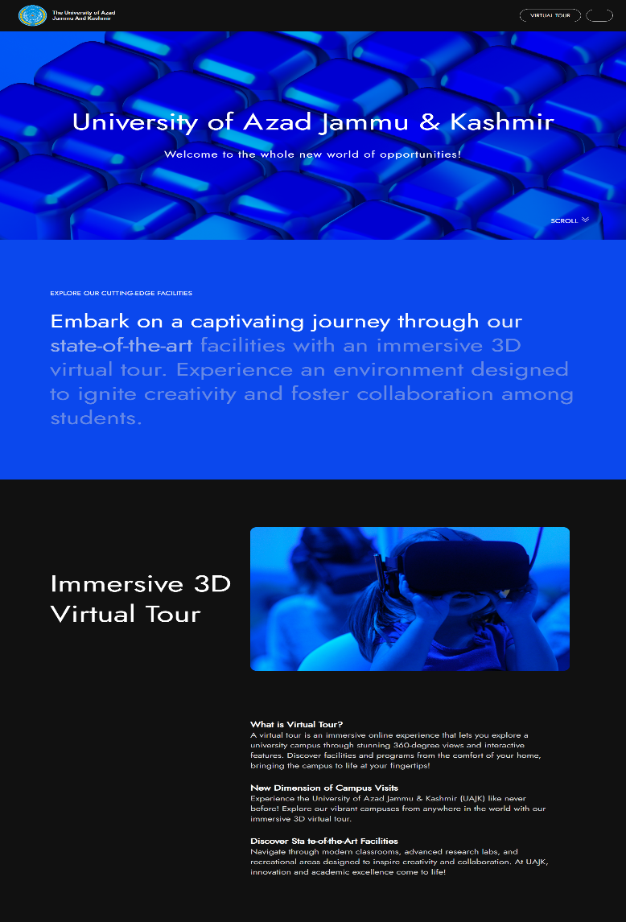

## • Introduction page

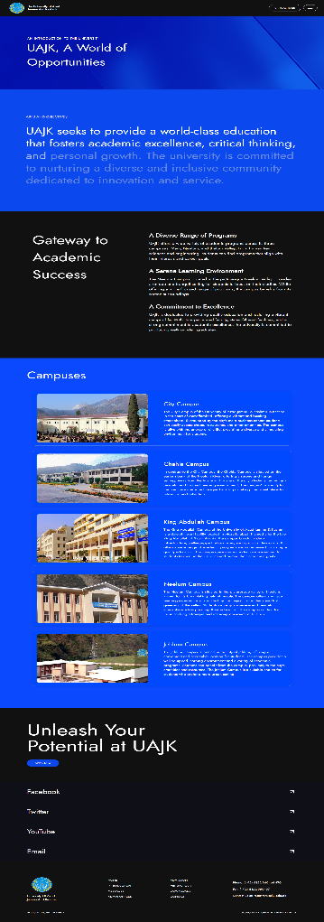

## • News Section



## • Login page



## Signup page

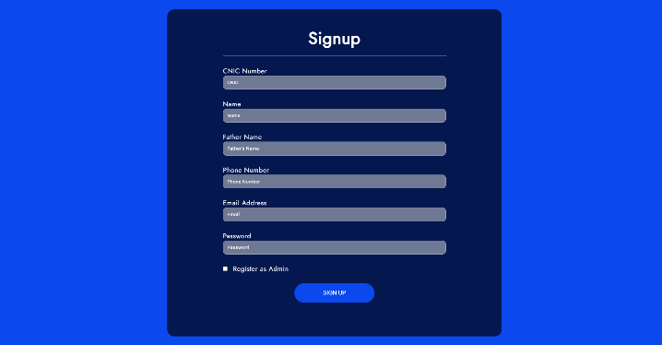

## Admin Login Page



## Admin Offices:

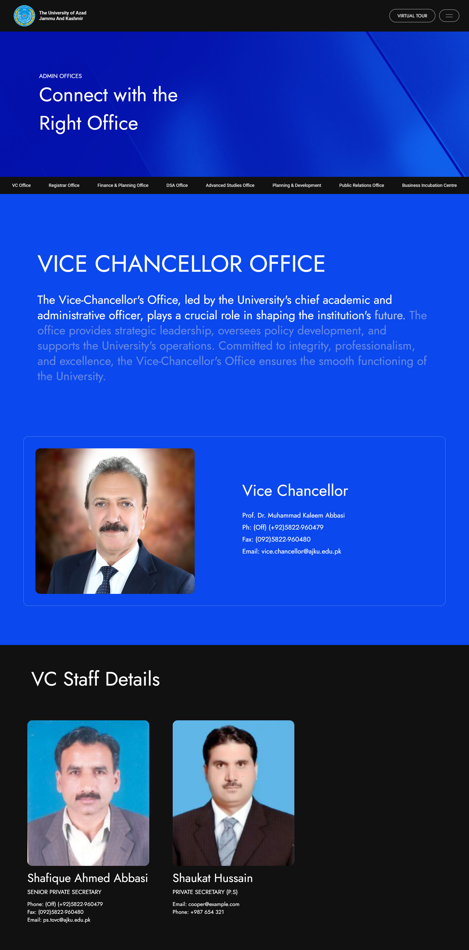

## • Virtual Tour

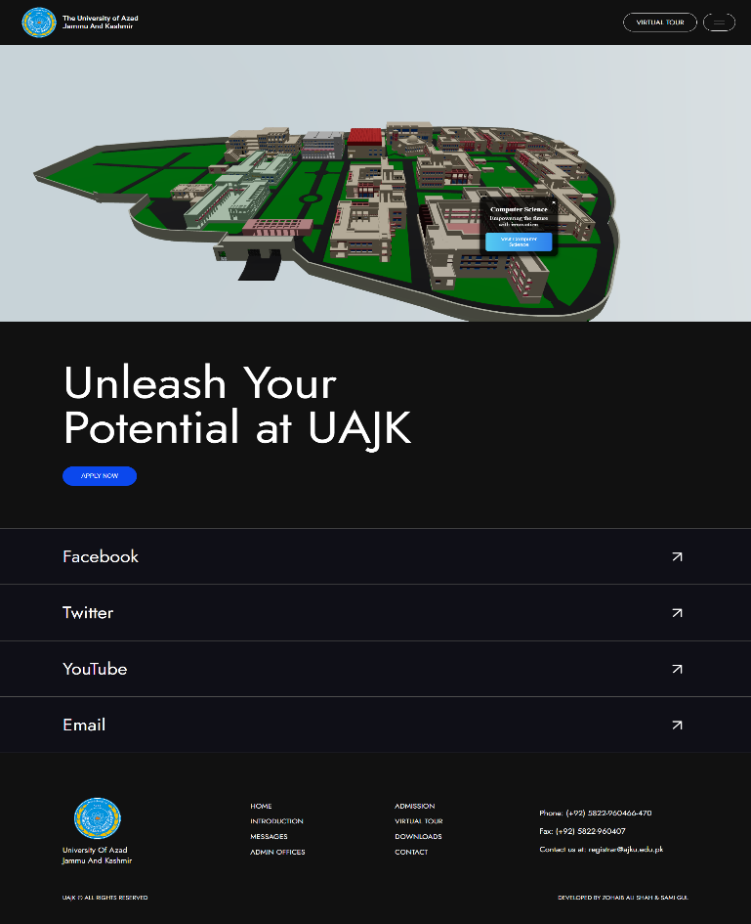

## • Department Page

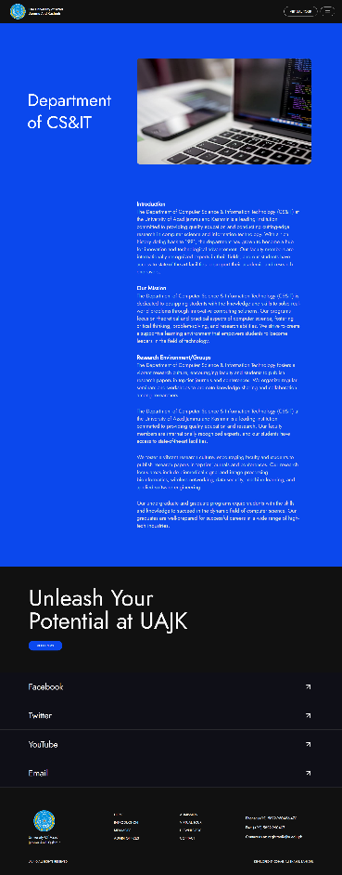

**•** Student Dashboard:

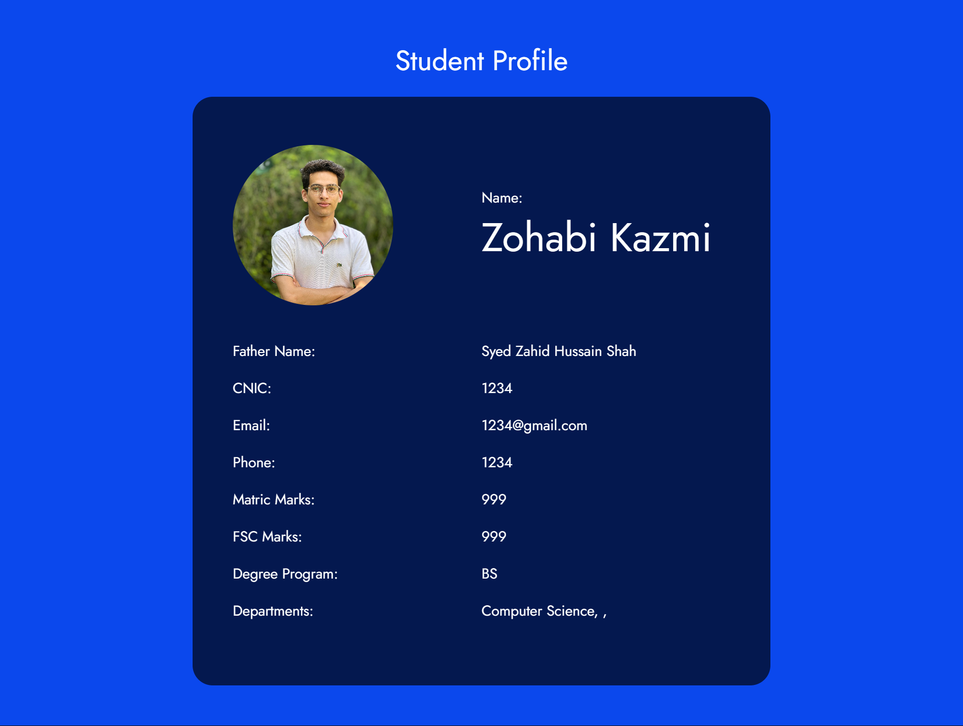

**•** Admin Dashboard:

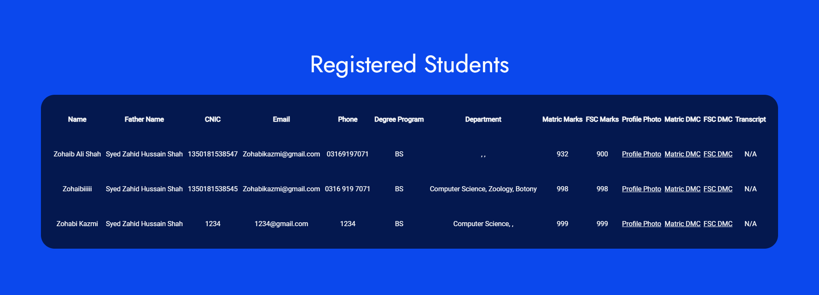

## CONCLUSIONS & RECOMMENDATIONS

## Achievements

We feel very proud after the development and implementation of our final project, *Revamping of the UAJK Portal: Unveiling New Dimensions through Virtual Exploration.* Although we possessed theoretical knowledge of web development, building a dynamic website that meets real-world requirements was both challenging and rewarding. With continuous guidance and support from our supervisor, **Dr. Zaki Hasan**, we were able to complete the project on time. Throughout the development process, we achieved the following milestones:

* Efficient project management and timely scheduling
* Improved skills in interacting with stakeholders and gathering user feedback
* In-depth system analysis and effective data collection
* Hands-on experience with website design, modeling, and 3D virtual tours
* Mastery of modern tools and technologies such as React, Node.js, and Three.js
* Creation of comprehensive user documentation to ensure smooth system usability

## Future Work

Further, there will be more campuses as a part of the virtual campus tour which will enable one to have a proper view of each site. Developing for the web-based system for admission will provide with new and improved features so that this online-based system will be streamlined along with functionality, efficiency and easy operation. In future, proper system updates or optimization work will be achieved in line with changing conditions and availability of newer technological means.

## Conclusion

In conclusion the development and implementation of the new UAJK’s portal is been successfully implemented. It is highly successful because it delivers a new, user-friendly, and efficient portal meeting the requirements of students, faculty members, and visitors during quest. In simple words, due to this advanced modern technology, containing an interactive 3D virtual tour, the system for the online admission would ensure proper access and interaction. It is indeed a great learning project experience, which will enhance us with practical skills for development in systems, interactions between users, and even handling projects. We are sure that the improved portal would enhance the university's presence online, simplify various administration processes, and also allow all users to be surrounded by an enriched digital life.

## Recommendation

Further upgrades must be done on the UAJK portal for maintaining the value of the portal to usability. Future releases are upgrading virtual tour to the complete and encompassing all of university buildings, campuses, and all university landmarks. More effective user experience will come as there is continuous upgrading done online admissions system through inclusion of features such as monitoring live application status with automatically giving notification. Regular collection of user and stakeholder feedbacks would keep the portal alive and help evolve to better serve emerging needs. More importantly, accessibility features as well as optimization on the mobile platform will further boost utility and engagement.

## Accessibility and Mobile Responsiveness

It ensures that its UAJK portal is standardized according to the standards of web accessibility:  
Accessibility features of web content guidelines include alt text on images and support for screen readers to ensure navigation by keyboard alone. It will also be very responsive when portal features precise adaptability that cuts across all devices. From the smartphone to a tablet, it will always be quite usable, and even access to information and service will not be a bother while one is on their way to somewhere. In this way, all the platforms are going to end up with a smooth uniform experience.

## Integration of Advance Features

Additional features added to the UAJK portal will facilitate betterment in user experience. In the dashboards student as well as faculty will view resources and information useful for them. AI Chatbot will help in querying instant answers about admissions course, and campus events-to make it interactive In VR and AR, interactive campus tours and other forms can be used. This includes an all-inclusive events management system for easy views and sign-ups and management of participation in any activity without friction. Online payment processing, tuition and fees, scholarship applications, and career services are also accessible. Generally, these advanced functionalities will grade the portal into much-needed resources for the university community.

## Analytics and Data-driven Insights

The UAJK portal will enable analytics and data-driven insights to improve decision-making and the user experience. It will help monitor student performance, admissions, and website interactions in such a way that administrators get actionable insights. Predictive analytics will help in enrolment forecasting and optimize resource allocation besides showing areas of improvement. The dashboards with real-time metrics will allow the staff to monitor system performance and student data insights to provide guidance for personalized learning paths. It will not just make the running of universities smoother but also deliver data-informed strategies for ensuring higher academic outcomes and institutional growth.

## REFERENCES

* <https://react.dev/>
* <https://www.youtube.com/watch?v=FxgM9k1rg0Q&t=964s&ab_channel=ChaiaurCode>.
* <https://stackoverflow.com/>
* <https://www.w3schools.com/>
* <https://gltf.pmnd.rs/>
* <https://threejs-journey.com/>
* <https://www.youtube.com/watch?v=EymaBUryzpI&list=PL2ksDap3jYZs-YQyaxFTZ7Gs0om2MpMbL>
* <https://www.youtube.com/watch?v=-mJFZp84TIY&list=PLu0W_9lII9agx66oZnT6IyhcMIbUMNMdt>
* <https://www.youtube.com/watch?v=n6UPwT2hf_g&t=3s&pp=ygUTM2Qgd2Vic2l0ZSBzaGVyaWFucw%3D%3D>
* <https://threejs.org/>
* <https://www.freecodecamp.org/>